Ant Esports Crystal Dual-Chamber ARGB Gaming Cabinet – White

The Ant Esports Crystal is designed to elevate your gaming experience to new heights, a gaming cabinet that combines cutting-edge design with unparalleled performance. With its unique dual-chamber layout and captivating clear glass front and side panels, the Crystal is not just a cabinet – it's a work of art that showcases your rig's inner beauty.Designed to accommodate even the most demanding setups, the Ant Esports Crystal offers an expansive interior that can house E-ATX motherboards, allowing you to harness the power of top-tier components. The Crystal's spacious design provides ample room for high-performance CPU air coolers of up to 168mm in height, ensuring optimal cooling efficiency for your rig.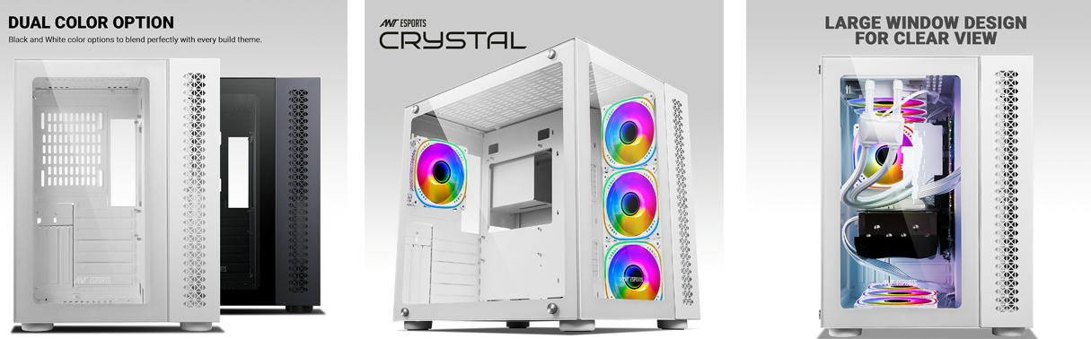Cooling enthusiasts will revel in the possibilities that the Crystal presents. Equipped to handle the most intensive gaming sessions, this cabinet supports up to a 360mm radiator on top, enabling superior heat dissipation and maintaining peak performance. With the ability to install up to ten 120mm fans, you have the freedom to fine-tune your cooling setup for ultimate thermal performance.Storage versatility is another highlight of the Ant Esports Crystal. Offering adaptable storage options, this cabinet can accommodate two 3.5" HDDs or one 2.5" SSD and one 3.5" HDD, ensuring that your gaming library and important data are well within reach. Say goodbye to storage limitations and hello to a seamless gaming experience.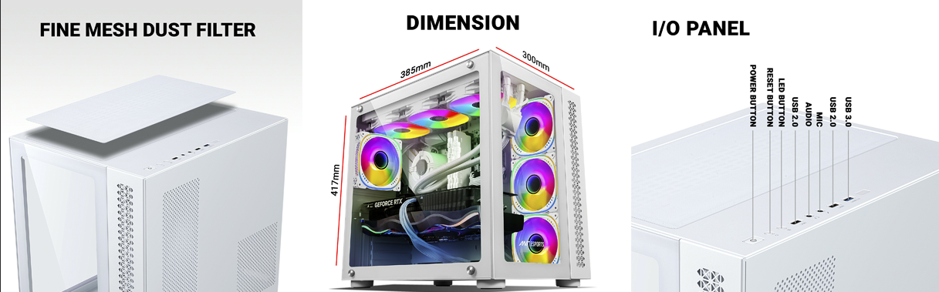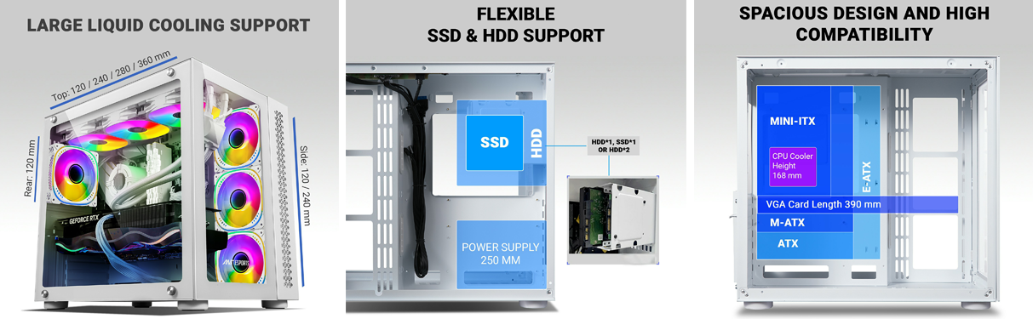Featuring a cutting-edge vertical graphics card mount, the Crystal lets you showcase your prized graphics card in all its glory. With support for cards up to three slots wide and a maximum length of 390mm, you can flaunt your hardware while maximizing airflow for optimal cooling. Your rig's graphics performance will never be compromised.The Ant Esports Crystal doesn't just house your gaming setup; it transforms it into a mesmerizing display of technology and artistry. With its dual-chamber design, crystal-clear glass panels, and support for high-performance components, this cabinet is a testament to the marriage of form and function. Elevate your gaming rig to the next level – choose the Ant Esports Crystal and experience gaming in a whole new light.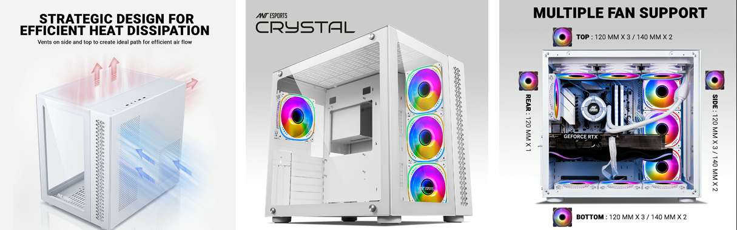

* **Dual Chamber Design:** The Ant Esports Crystal gaming cabinet features a thoughtfully designed dual chamber layout that optimizes airflow and cable management. This design separates the components into distinct compartments, ensuring efficient heat dissipation and minimizing clutter for a clean and organized build.
* **Elegant Clear Glass Aesthetics:** With its sleek clear glass front and side panels, the Crystal cabinet offers a stunning showcase for your gaming rig's hardware and RGB lighting. The transparent panels not only let you display your high-performance components but also provide a visual feast for gamers and enthusiasts.
* **Extreme Compatibility:** Supporting up to E-ATX motherboards, the Crystal cabinet is equipped to handle a wide range of system configurations. Its generous CPU cooler clearance of up to 168mm accommodates even the tallest air coolers, while the top panel can house up to a 360mm radiator for liquid cooling enthusiasts, ensuring optimal cooling performance.
* **Ample Cooling Options:** Designed with enthusiasts in mind, the Ant Esports Crystal can accommodate up to ten 120mm fans, allowing you to fine-tune your cooling setup for maximum airflow and heat dissipation. This abundance of fan mounts empowers you to maintain ideal temperatures during intense gaming sessions or demanding tasks.
* **Versatile Storage Solutions and GPU Support:** The Crystal cabinet offers flexible storage options, supporting two 3.5" HDDs or a combination of one 2.5" SSD and one 3.5" HDD. Additionally, the vertical graphics card mount capability allows you to showcase your powerful graphics card (up to three slots wide and 390mm in length) in an eye-catching orientation, adding another layer of customization to your build.